pH table KPO4 and NaPO4 buffers

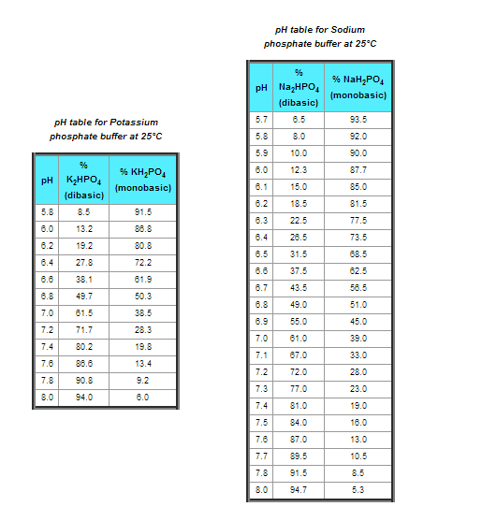

POTASSIUM PHOSPHATE BUFFER recipe

Make the following two solutions and then mix them to obtain the correct pH

1. 1M KH2PO4 (MONObasic)- MW - 136. Add 136g to 750 ml water.

After it has gone into solution, bring it to a final volume of 1 liter.

2. 1M K2HPO4 (DIbasic) - MW 174. Add 174g to 750 ml water. After it

has gone into solution, bring it to a final volume of 1 liter.